How to put your Hair in a Ballet Bun

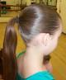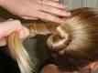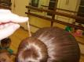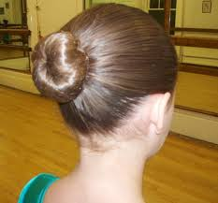
Materials-
Spray bottle filled with water
Hair Gel
Hair Spray
Hair pins/ Bobby Pins
Elastic Band
Hair Brush- old-fashioned bristle brushes work best, not the vented kind
Hair Net

- To start, spray hair with water and use fingers to comb hair gel through hair. You really can’t have too much hair gel, so don’t hold back. Gather the hair and pull it back.

- Use the brush to smooth out any bumpy or uneven areas. Form a ponytail at the back of the head. The position of the ponytail determines where the bun will be. If you would like a low bun pull the pony tail down to the nape of the neck. Because some classes have hats or headpieces a low bun or one at the back of the head rather than a high bun is preferred.
Use an elastic hair band to secure the ponytail.
A tidy ponytail with hair pulled back snuggly is the key to a good bun.

- Apply more water and/or gel to the pony tail to smooth hair out. Twist the ponytail.

- Coil the ponytail into a tight circle around the hair elastic.

- Use hair pins all around the bun to secure it to the head. Pushing the pins in straight and then giving a little twist and push to catch the hair helps to really hold the bun.

- Wrap a fine hair net that matches your hair color around the bun. The hair net should be twisted and wrapped around the bun until in covers it tightly. Add more hair pins around the bun to secure it.

- For extra hold, when bun is secure use hair spray.

